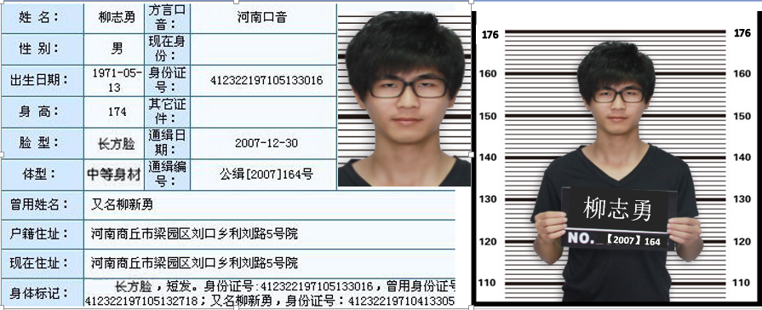

1. 你看到了什么？
2. Circle the body parts and adjectives that describe the man’s appearance.
3.
- What is the purpose of this post?
- What happened to the man?
- What is the date for?
- Where does he come from in China?
- How old is the man?

资料来源
http://news.oeeee.com/a/20080106/50748.html

